PMEducation

THREE POINT ESTIMATE

WHAT IT IS

The Three Point Estimate is a technique which is used to calculate a representative estimate. We know that with every estimate there is a measure of uncertainty or probability. The accuracy of single-point estimates can be improved by considering estimation uncertainty. This tool applies probability to the estimate.

To get a more representative estimate than a single most likely estimate, we can ask, “What is the likelihood the actual value will be 10% over my estimate, 15% over, and so on.” These percentages, or amounts, over and under estimate can be graphed against their likelihoods and that is the probability distribution curve.

Two probability distribution curves are in common use, the Beta Distribution and the Triangular Distribution. Each distribution has its own calculation for Three Point Estimating.

The Beta Distribution is representative of phenomena that occur in nature, and is preferred when we have a lot of historical data. It is useful for representing distributions that are bound on both sides, like probabilities. Beta Distribution is more useful for similar types of projects, and when experts are providing information based on historical evidence & experience. For these reasons, the Beta Distribution uses a weighted average calculation in Three Point Estimating, sometimes called a PERT calculation.

If we are doing a project for the first time, and there is no previous history of similar projects to fall back on, it makes more sense to use the Triangular Distribution, as there is no basis to give more weight to a particular estimate. Thus, a Triangular Distribution is more suited for judgmental data estimates, which are not based on a lot of experience or expertise. The Triangular Distribution uses an unweighted average calculation in Three Point Estimating.

The Three Point Estimate can be used for Time, or Cost, or any other estimated quantity.

HOW IT WORKS

- Begin with the Most likely value for the estimate.

- Then ask, what is the most (reasonably) optimistic estimate value, and what is the most (reasonably) pessimistic estimate value.

- Decide the probability distribution (Beta or Triangular), based on the discussion above.
__
- Calculate the Three Point Estimate, X , from the formula on the appropriate curve below. Use this calculated value in your planning.

KEY ELEMENTS

For this method to be effective, the following key elements must be used:

- Representative selection of knowledgeable participants
- Subject Matter Expertise to bring reality about similar project activities
- Agreement in the group about the terms: Optimistic, Most likely, and Pessimistic

ADVANTAGES and DISADVANTAGES
Of THREE POINT ESTIMATE

ADVANTAGES

- Provides a more accurate estimate
- Relates estimate to probability
- Clarifies range of uncertainty around the estimate
- Helps reduce high and low biases
- Provides vehicle for Team Member involvement

DISADVANTAGES

- Requires knowledge to determine reasonable optimistic and pessimistic values
- Terms of Optimistic, Most likely, and Pessimistic are subjective
- Takes more time than Single Point Estimates

FINAL NOTE: The Three Point Estimate is a tool to select an estimating number when there is uncertainty around what the correct estimate should be. This tool assumes a probability distribution of the estimate, then works with 3 points on the probability distribution curve to calculate the most likely estimate.

Finding the best possible inputs for Optimistic, Most likely, and Pessimistic estimates will provide the best possible outputs for Three Point Estimates.

Below you will find the Probability Distribution Curves for Beta Distribution and for Triangular Distribution. The Three Point Estimate calculation ( ͞x ) is shown on each curve.

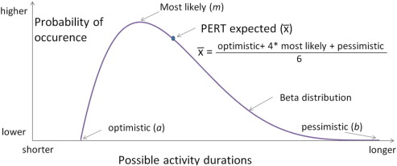

BETA DISTRIBUTION CURVE

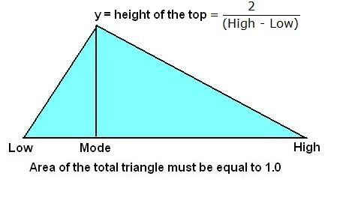
Probability of occurrence
higher
lower

shorter Possible activity durations longer

The Low, Mode, and High values are: optimistic, most likely, and pessimistic, respectively.
_
Three Point Estimate: X = optimistic + most likely + pessimistic
3

TRIANGULAR DISTRIBUTION CURVE

